**Trend Lines and Reference Lines**

**Trend Lines**

**Statement:**

Using “World Population dataset”, which contains one record for each country for year 1960, 1965, 1970……2015, measuring population. Create a visualisation, showing the difference in trend in population for different periods of time, of Afghanistan and Australia.

(Use World Population 1960-2015 dataset.xlsx)

**Solution:**

Using the given dataset, let us look at historical trends in population in various countries.

**Step 1:** Connect → Microsoft Excel → World_Population(1960-2015) → OK → Sheet1

**Step 2:** Drag: Year → Column, Population → Row, and Country Name → Marks Card → Colour Shelf.

**Step 3:** To edit Axis:

Right Click on Population → Edit Axis → Fixed → Fixed Start – Fixed End (4K – 30M) → Apply →Ok

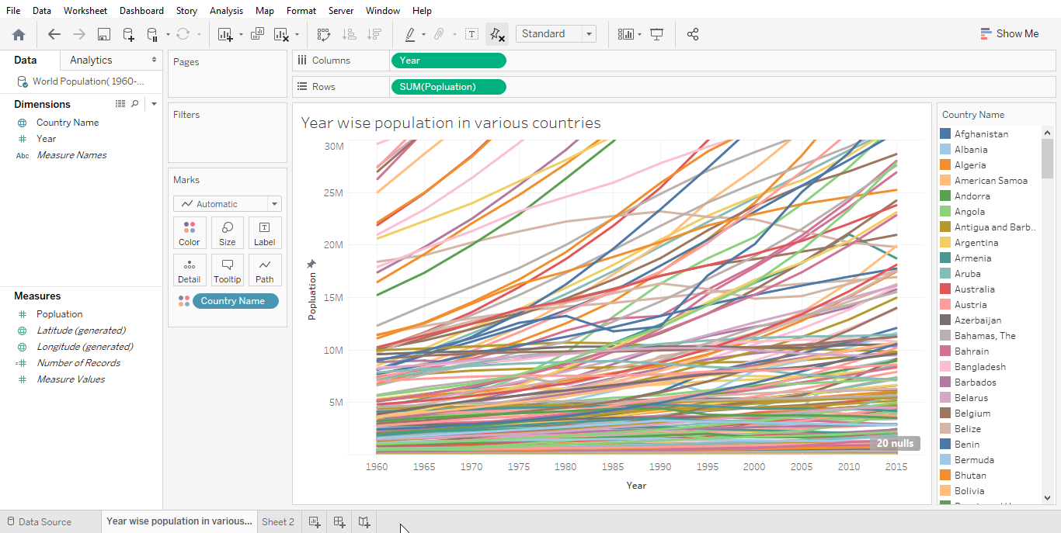

* Now, create a visualisation which shows the change in population over time in Afghanistan and Australia.

**Step 4:** Country → Drop Down → Edit Filter → Select Afghanistan and Australia → Apply →OK

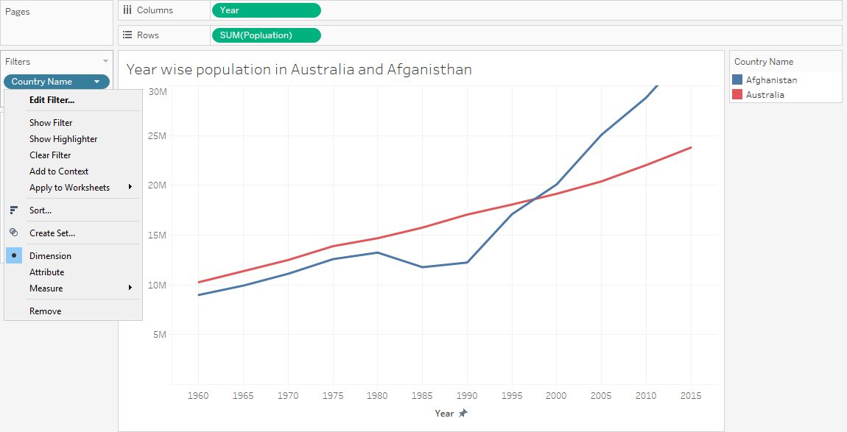

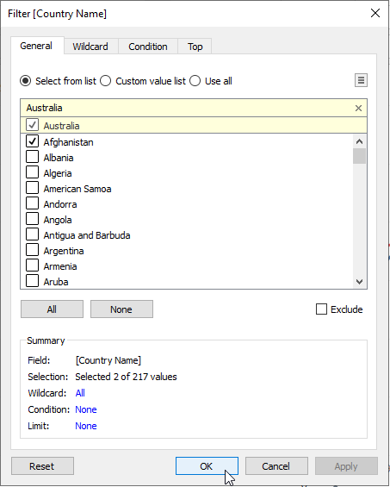

**Step 5:** Drag Country Name →Marks Card → Colour Shelf and Label Shelf

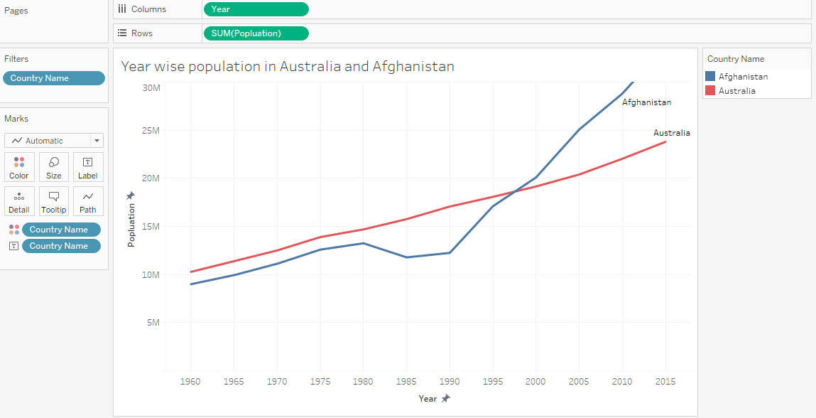

* From this visualization, we can see:
* The growth in population of Afghanistan and Australia, was similar up to 1980.
* Afghanistan’s population declined until 1988 then the population of Afghanistan started increasing.
* Around 1996, Afghanistan’s population exceeded that of Australia.
* Let us observe the above-mentioned observations using Trend lines:

**Step 6:** Analytics → Model → Trend Line → Drag **Trend Line** to Canvas → Select Linear Trend Liner.

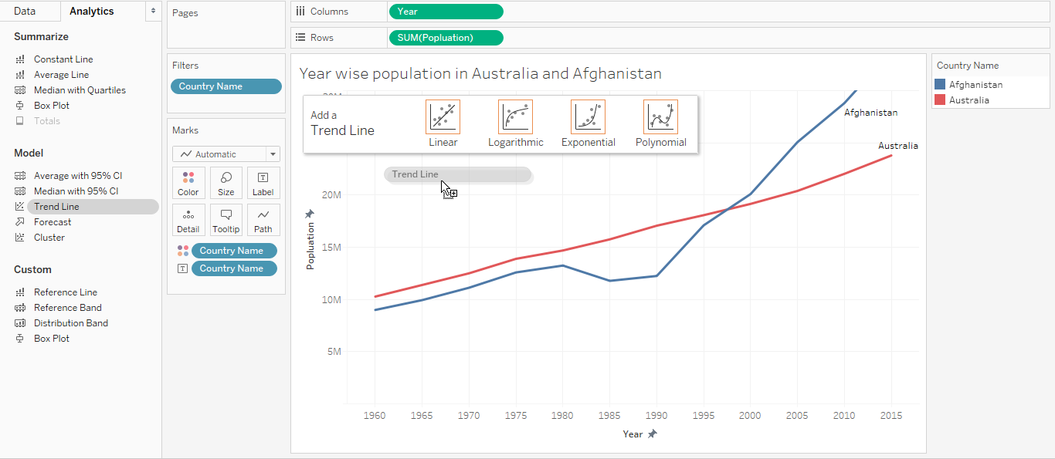

* After adding Trend Line to our view, two trend lines are reflected one for each country.

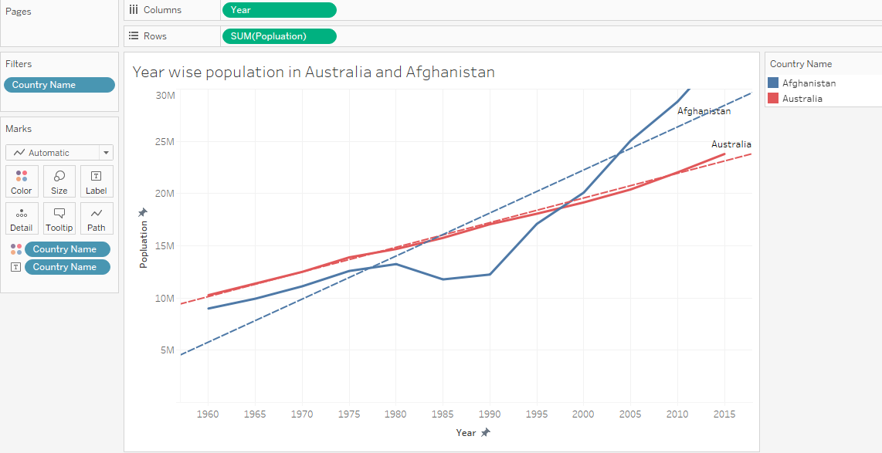

* Add So far, we have observed population of Afghanistan increased and decreased over years. Now, we will visualize different trend lines for increased and decreased time periods:

**Step 7:** Create a parameter to represent different time periods:

* Dimensions → Drop Down → Create Parameter → Create Parameter Dialog Box
* Create Parameter Dialog Box → Name (here Time Period) → Properties → List →OK

**Step 8:** Create a calculated field called Time Period which defines discrete values for different time periods.

* Dimension → Drop Down → Create Calculated Field → Name Calculated field as Parameter (here Time Period) → Write code → Apply → Ok

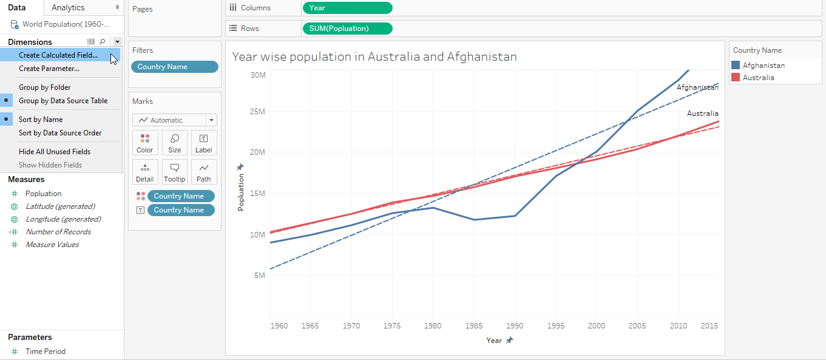

**Step 9:** Add selected salesperson and difference from selected to rows.

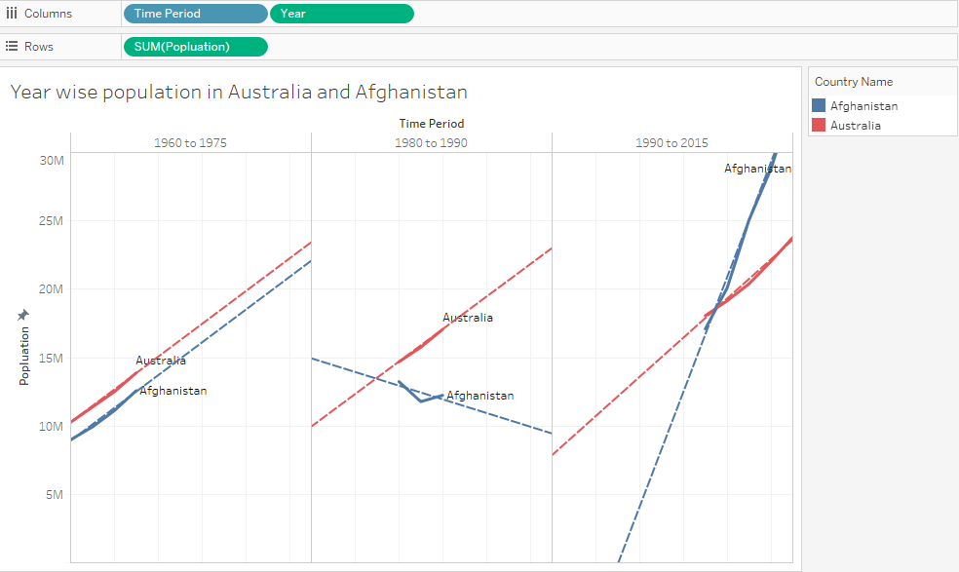

* Now, we can visualize the difference in trends for different periods of time:
* From 1960 to 1975, the growth in population of Afghanistan and Australia was similar
* From 1980 to 1990, Afghanistan’s population declined
* From 1990 to 2015, Afghanistan’s population exceeded that of Australia